

Staffordshire Games Institute

GAMES DEVELOPMENT PROJECT

PROPOSAL

Name: Ethan Taylor
Enrolled Course: Games development
Student Number: 22039755
How should generative AI be used in the development of games?

Contents
What Problem are you trying to solve? 3
How does this Project help your employability? 3
Areas for Research, Investigation and Methodology: 5
What are the deliverables? 5
Planning Documentation 6
Sample of work you have completed to this date (relevant to project): 6

What Problem are you trying to solve?
Generative AI (GAI) is a topic being widely discussed in the industry currently. Lots of companies are rushing to implement new workflow that uses GAI as it holds many advantages such as it being highly cost-effective to use. With these advantages comes problems and GAI is no exception to this rule, one of the main issues which is what will be discussed and solved will be if it is ethical to use GAI instead of hiring developers to make the content for the company.
The goal of this research is to determine if using GAI is effective and if it would be worth for different types of companies to invest and set up the use of GAI over hiring the equivalent staff for these jobs.
The result of this research could have a major impact on the games industry as if using GAI instead of employees is the answer then lots of people could lose their jobs to GAI, this is where the ethical arguments come into play as even if it is more cost effective and the consumers prefer the use of GAI it may not be the ethical thing to do.
How does this Project help your employability?
This project will increase my understanding and knowledge of GAI which will allow me to use it for projects in the future. It will also help me find an answer to the ethical questions around using GAI and if I should use it going forward. This project will help me decide what game studios and companies I would like to work for/with dependent on their values and perspective on the ethics related to using GAI.
https://uk.indeed.com/viewjob?jk=4dd8c5df2df25773&from=shareddesktop
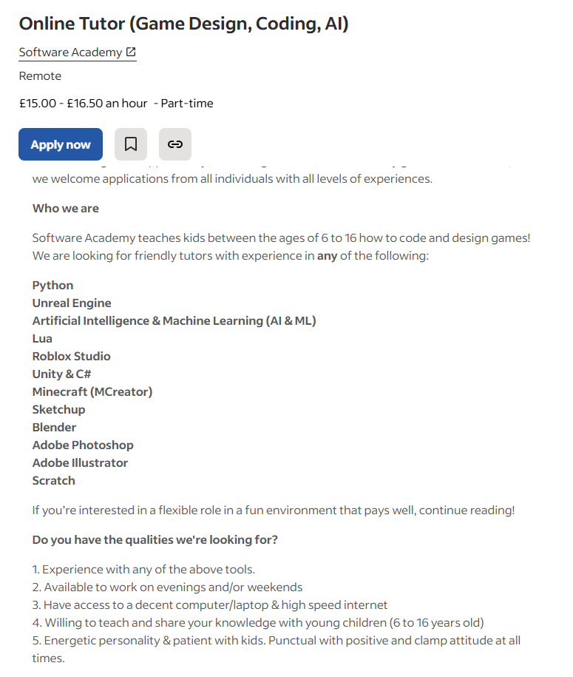
This job opportunity requires knowledge and experience into any and all parts of games and programming. The applies to the knowledge that will be gained from researching GAI and its place in the games industry.
Unreal Engine (UE) is also listed as an area on this listing and the project to go alongside this research will be produced using UE further confirming the use of this research in obtaining a job.

https://uk.linkedin.com/jobs/view/game-developer-at-fen-research-ltd-4302530140
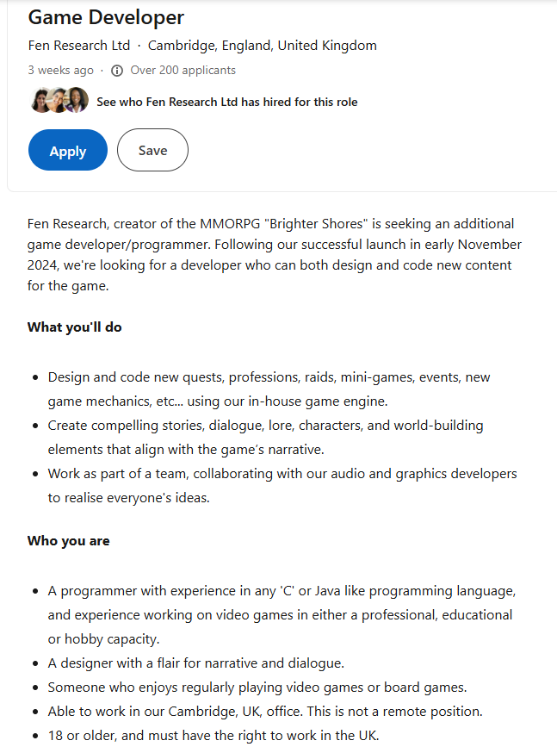
In this job listing the employer is looking for a developer/designer to help make new content such as quests, raids, mini-games and events. This will have a lot to do with creating dialogue which is the area of this research using GAI in dialogue options.
The project to go along side this research covers the criteria set so that alone would prove the qualifications and help to get this job.

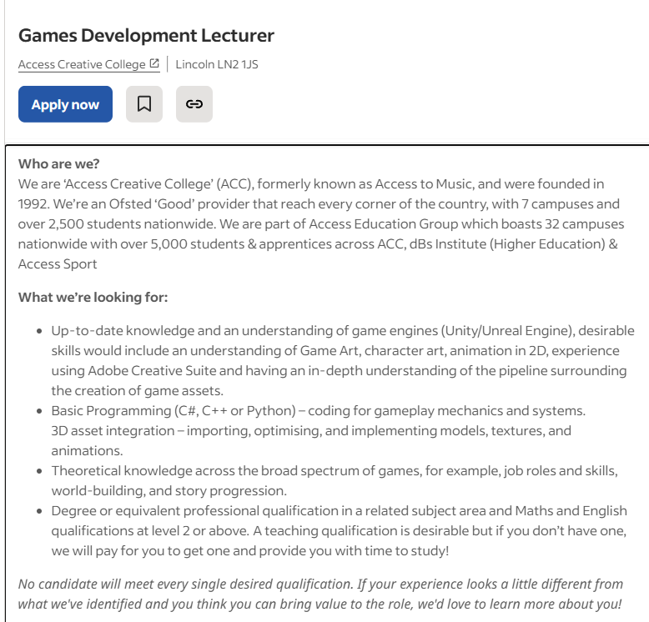
https://uk.indeed.com/jobs?q=games+development+joiner&l=&from=searchOnDesktopSerp&cf-turnstile-response=0.Foz46regtIogOzO9jGJNdUzmVkAuQaHm_xdvMZUFx7Bc2si_FwpsdCLw0M7bgdALsnvzdzm71Dg1tCHMtFzzZFP16VuJCXltGZlL4DWl_27IXsU39Ug8o3uZ5J603dYmeudNvnR9ev7dG39vJu5f3yary5EiaZXR-1S-LE4DcFezbfs4cFU1NyxKvqeMVDLW_yO6NpFexjES4Fy19VBcTog522JE3ES3-N2aBCt3LJXSV_i4lYpZMdQuC5Yo0n7fMGOWaTUdA6WR4xNI2wPIslulTU3g5srKZB9QB0qu1hDE33col4fqITczAI1saUEIVj1oNS3HlOmLi4KNgPkz1InU5Z9BiZBzcSp2ehXD647pkFxt1HMFA4a2vcDW-ogmYAtzB1KEjILUgWrXMpON6hKmf5f4FiniAkkcqFtW7aDA54n6FFen9Ec13wl1d0d9PuEkFwabov1kwyUj0ndkau-4ZFE22VxYHxRU8NTcMwZZuIDmdLqxVCNFAEcnWB8xxM3e1uVcd8zJqZyGF6z2Br4K0a5KT5n-qu_OoAnw6tMk2C7Advq6pOWjsLDKVdodoNZRts4zxY6B5oKo_DG5zUZHT0FlTcgIj5Qll6KwAiszApuKj6jyFqfrwJz3cvb8U6GTIl-jIAVFZiEB_zZ-SZ8UGFlHSi90erOc64jMD2Gw9TBKFDZPt58UXppmkB6CikSgazQpaW5WIu9PO42V1msiue6js6Dj3aey2V_UAhm2c7AiKBh_GGay61TyuD1HxP2lkTdJ_T1sDJDWCQPgB_L84ZryAiHpMbH9yLxMMBLRqaSkcdSCzWgftC5D6-bJ1FFNwnX_t1Va6abj47txZRfTWBD-pPYDd86vKPCtrfl9d0bZfoZiX3EOZjeBXPY5-VCnXmMGvFX2bf88KK7VgDguql4pTQa0i35H7aI_oJSP2sqzghOJWdJrjEicD10v.fxWOh8-tBKInfYm3c6DrKA.5e1974bbbfa6f09f85486d35083b4555dbe91efd7e3a6799d1416ae0841bf9ff&vjk=3d8b16bc4277a763

This job is looking for people with basic knowledge and skills to teach games development to students. This could be classed as an entry level job that would be obtainable using this research and project as an assessment of my skills and knowledge on games.

Areas for Research, Investigation and Methodology:
- What is GAI.
- What is the development process.
- How is GAI used in the development process.
- The cost of using GAI compared to hiring artists.
- The time it takes designers to male dialogue.
- Project pipelines.
- The bottlenecks that can be caused by missing dialogue.
- The negative response from consumers when using GAI.
- The thoughts of developers when using GAI.
- The popularity of games/media using GAI.
- The requirement for realistic dialogue.
- The accuracy of GAI.
- The versatility of GAI compared to set dialogue options.
- Games/Media that uses GAI already.
- The current state of the games industry.
- The key differences between large (AAA) companies and indie studios.

My approach will be to dive into each area listed above and other areas that I will find throughout my research in order to gain a greater understanding of the topic. This will be done by reading through articles and research papers on the areas and using these to obtain an answer to the proposed question. I will also create a project to go along side and help supported/prove my findings in the field being researched, and I write a development log to explain the development process and reflect on the results shown through this.

What are the deliverables?
A supporting project that will have two versions. One will be using GAI, and the other will use human made dialogue. I will make a village quest scenario which will contain non-player characters (NPCs) the users can speak to and a simple quest for them to complete. As stated previously there will be two versions of this one made by hand and the other with GAI. Specifically, the dialogue options will be what changes. A questionnaire will be completed by the user afterwards that will ask about their thoughts on the dialogue and which they preferred, then they will be informed that one was using GAI and for them to answer the questions again to see if their opinions changed. Alongside this will be a development log explaining the development process and the results as well as what this means with the research that has been completed.

Planning Documentation
https://trello.com/invite/b/68e7de0044a6f7af02f51675/ATTI653f9f2e9f97bbbd7cead2d2243ca585CFCBE8C0/dissertation

Sample of work you have completed to this date (relevant to project):
Over the years I have completed several projects that provide evidence to my capabilities in using UE and game development as a whole. Specifically for this project I will need to be able to set up environment and village assets, create a simple medieval quest and make dialogue for the NPCs.
https://digitalacademy.staffs.ac.uk/forum/index.php?/topic/57576-taylor-ethan-t039755m/
The link above will showcase the development and output of a project where I created multiple assets from scratch and put them together inside a scene in UE in order to create an environment for them.
https://digitalacademy.staffs.ac.uk/forum/index.php?/topic/66219-taylor-ethan-t039755m/
The link above showcases the development and output of a project where I created an arena using pre-made assets an some simple UI that I made to showcase some mechanics that I developed.
https://digitalacademy.staffs.ac.uk/forum/index.php?/topic/77457-taylor-ethan-t039755m/
The link above showcases the development and output of a project where I created a map and environment using assets I sourced from the UE marketplace (before it moved to FAB) and how I created a tutorial using simple dialogue pop-ups upon certain pick-ups in VR.

